[Ecosystem Simulator]
User Interface Prototype

Date | November 14, 2014
Version | 1.0
Status | Draft
Author | Nguyen Van Chuc An, PM
Reviewed by
Approved by

Revision History

Date | Version | Description | Author
November 14, 2014 | 1.0 | Design User Interface Prototype | Nguyen Van Chuc An

Table of Contents

1 Introduction 4
1.1 Purpose 4
1.2 Scope 4
1.3 Definitions, Acronyms and Abbreviations 4
1.4 References 4
1.5 Overview 4
2 List screens 4
3 Flow of screens 5
4 Main Screen 6
5 Simulator screen 7

Introduction

Purpose

Describe purpose of screens of Ecosystem Simulator

Scope

Definitions, Acronyms and Abbreviations

STT | Term | Description

References

Overview

List screens

No | Screen Name | Description
1 | Main Screen | Show options to manipulate simulator
2 | Simulator screen | Render creatures: carnivore, herbivore, plant, environment

Flow of screens

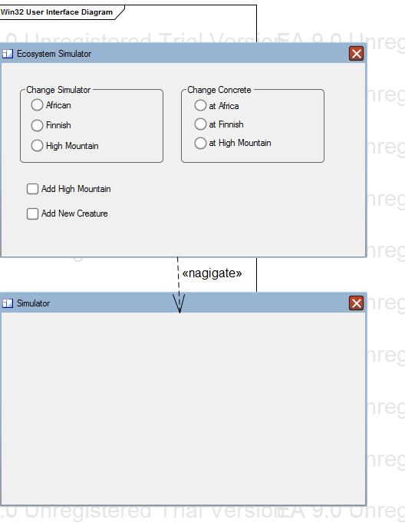

Main Screen

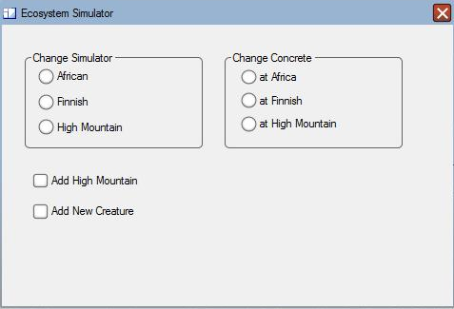

# | Display name) | Code name | Description
1 | Change Simulator | pnlChangeSim | Panel bound change simulator options
2 | African | rdbAfrican | Radio button African
3 | Finnish | rdbFinnish | Radio button Finnish
4 | High Mountain | rdbHighMountain | Radio button High mountain
5 | Change Concrete | pnlChangeConcrete | Panel bound change concrete creatures options
6 | at Africa | rdbAtAfrica | Radio button at Africa
7 | at Finnish | rdbAtFinnish | Radio button at Finnish
8 | at High Moutain | rdbAtHighMountain | Radio button at high moutain
9 | Add High Mountain | ckbAddHighMountain | Check box add high moutain
10 | Add new Creature | ckbAddNewCreature | Checkbox add new Creature

Simulator screen

# | Display name) | Code name | Description

